# CHAPTER 5: IBM HTTP SERVER AND PLUG-IN

## Theory

Web servers are one of the most important part of the multi-tier architecture and they provide scalability, security and performance. Web servers are defined to WebSphere Application Server as either managed or unmanaged node and in both configurations, they can be managed through administrative console. WebSphere Application Server can work with different web servers such as Apache HTTP Server, Microsoft Internet Information Services (IIS) and surely with IBM HTTP Server.

IBM HTTP Server (IHS) is a web server solution that is based on Apache HTTP Server. From version 7.0, Apache 2.2.8 version is used to build HIS. It can run on different operating systems such as AIS, Linux, Solaris and Microsoft Windows.

There are couple features added to Apache HTTP Server:

* WebSphere Integrated Solutions Console support
* Consistent installation via IBM Installation Manager
* Fast Response Cache Accelerator (FRCA), that improves serving of static contents, is available for AIX 5 and later and certain Windows operating systems.
* Dynamic content generation with FastCGI
* Multiple language and platform support.

The IBM WebSphere Application Server Web server plug-in is the connector between a web server and WebSphere Application Server. The main responsibility of the plug-in is to forward http requests from web server to the application server. Based on the applications that would be routed by the web server, there is a web server plug-in configured using the *plugin-cfg.xml* file.

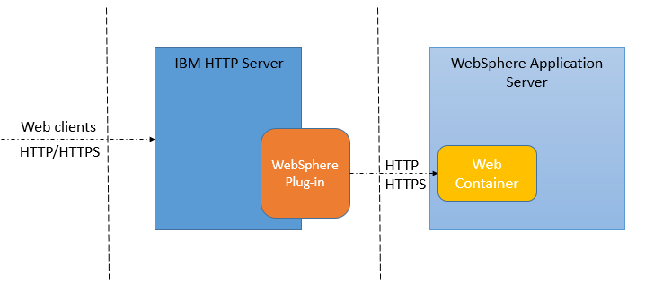

In a multiple applciation server environment, it is possible to configure plug-in as load balancer with failover capability. The plug-in also increase performance by serving the static content directly from the web server. It also increases security by putting an extra layer between the web server and the application server and having the possibility of using secure HTTP protocol.

WebSphere Customization Toolbox, (WCT), is a set of tools to manage, configure and migrate different parts of WebSphere Application Server. It has two different offerings with different combinations of tools:

* Embedded: It is installed during WebSphere Application Server installation and contains the “Profile Management Tool” and the “Configuration Migration” tool.
* Stand-alone: It is installed separately using IBM Installation Manager and contains the “Web Server Plug-ins Configuration Tool”, “z/OS Profile Management Tool”, “z/OS Migration Management Tool” and “Remote Installation Tool for IBM i”.

The “Web Server Plug-ins Configuration Tool” is used to configure web server plug-ins on distributed and on Windows operating systems. It can be used also to create web server configuration definition in the application server.

## AIM

The aim of the lab exercise is to install IBM HTTP Server, WebSphere Web Server Plug-ins and WebSphere Customization Toolbox using IBM Installation Manager. You will need to configure the web server and the Plug-ins to work together. Later, define the web server in application server using the configuration script created by WebSphere Customization Toolbox. When all the installations and configurations are ready, you will generate and then propagate the plug-ins via IBM Integrated Solutions Console for the sample application installed during the WebSphere Application Server.

In order to achieve this, you need following steps:

* Install IBM Installation Manager
* Install IBM HTTP Server
* Install WebSphere Plug-ins
* Install WebSphere Customization Toolbox
* Create web server definition using scripts created by WCT
* Generate and propagate plug-in for the default application

# Lab Exercise 5: IBM HTTP SERVER AND PLUG-IN

|  |
| --- |
| Install Ins.Man.  Install IHS  Install Plugin  Install WCT  Define Webserv.  Plugin Propag. |

## Install IBM Installation Manager

## Install IBM HTTP Server

## Install WebSphere Plug-ins

## Install WebSphere Customization Toolbox

## Create web server definition

## Generate and propagate plug-in

Install Ins.Man.

Install IHS

Install Plugin

Install WCT

Define Webserv.

Plugin Propag.



**Task 1: Install IBM Installation Manager**

**Step 1:** Change directory to the installation folder and then run “install”. From the interface, click on “Install” to start installation.

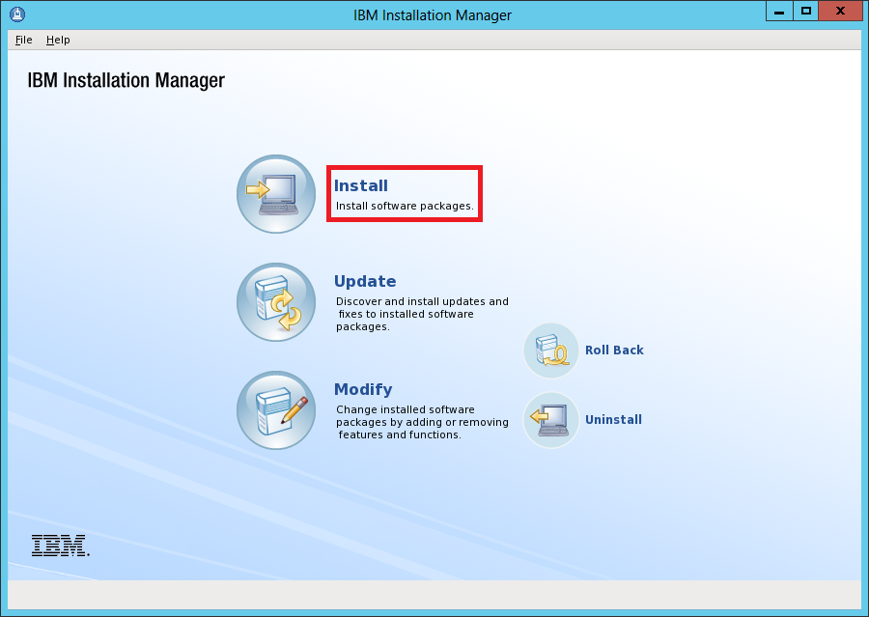

Install Ins.Man.

Install IHS

Install Plugin

Install WCT

Define Webserv.

Plugin Propag.



**Step 2:** Select “IBM Installation Manager” and then click “Next”.

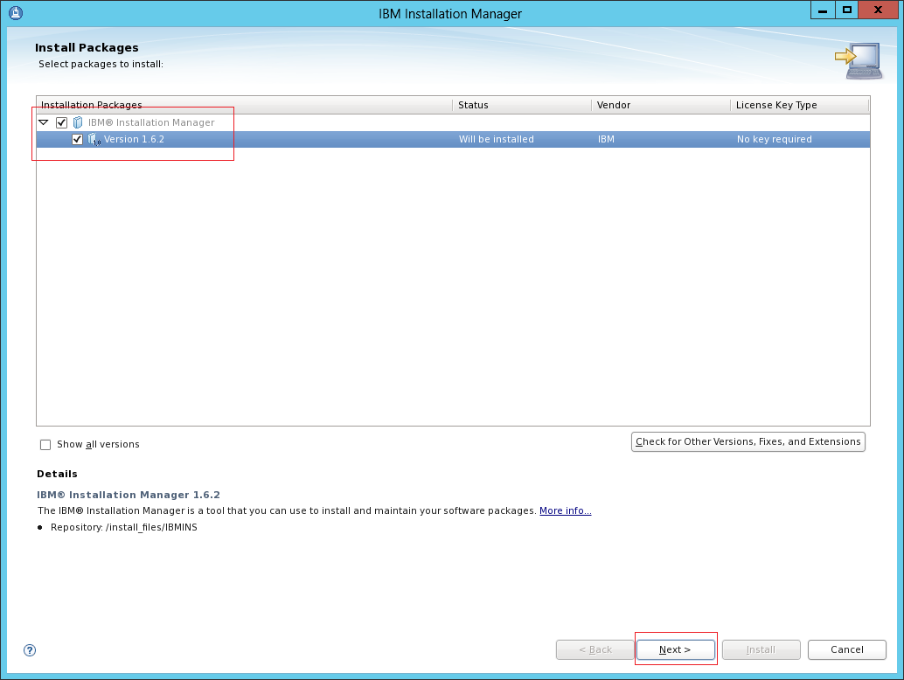

**Step 3:** Accept the license agreement and then click “Next”.

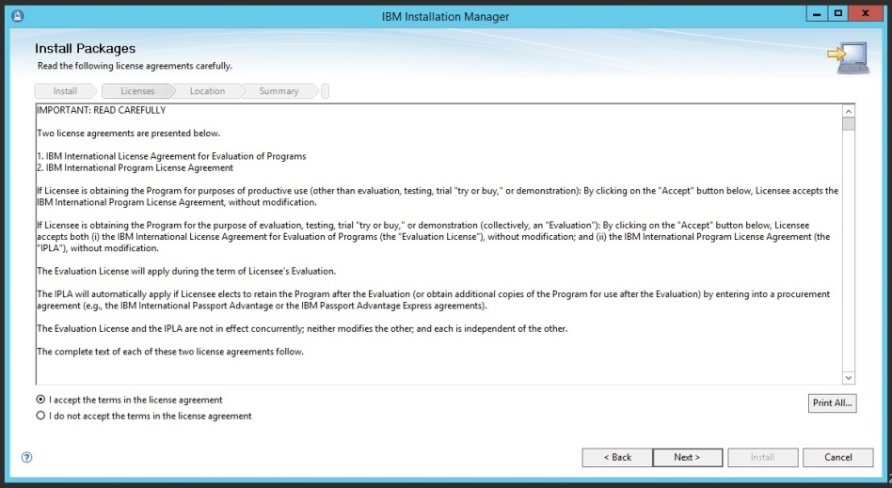

**Step 4:** Use the default installation directory (/opt/IBM/Installation Manager/eclipse), click “Next”.

Install Ins.Man.

Install IHS

Install Plugin

Install WCT

Define Webserv.

Plugin Propag.



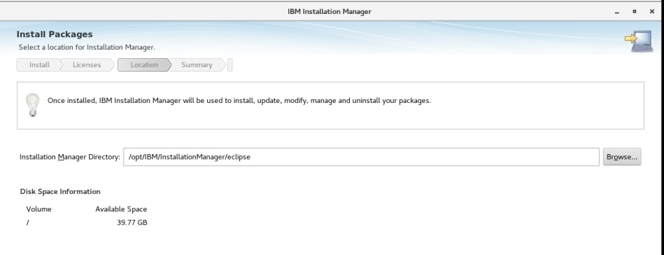

**Step 5:** Review the summary and then click “Install”.

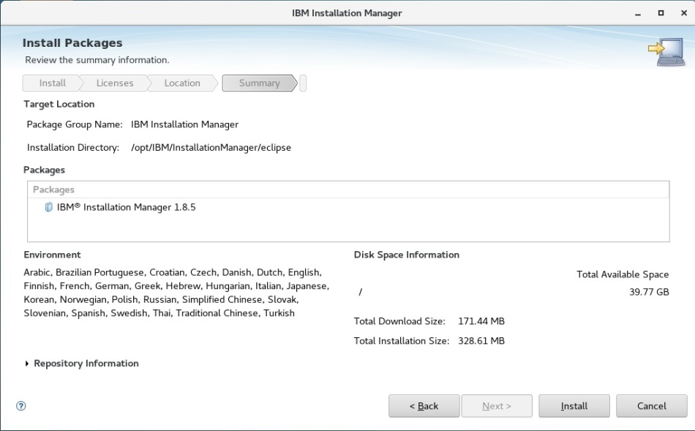

Install Ins.Man.

Install IHS

Install Plugin

Install WCT

Define Webserv.

Plugin Propag.



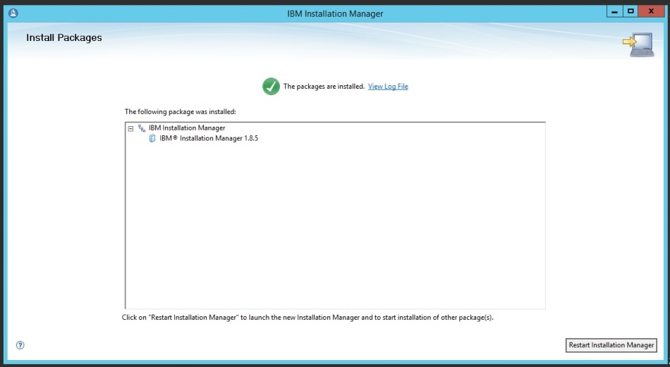

**Task 1 is complete!**

Install Ins.Man.

Install IHS

Install Plugin

Install WCT

Define Webserv.

Plugin Propag.



**Task 2: Install IBM HTTP Server**

**Step 1:** Start IBM Installation Manager under the directory. Add the repository via “File>Preferences”. Add IBM HTTP Server repository and IBM SDK v8.8.0. SDK is already installed but required as package for installation.

<http://www.ibm.com/software/repositorymanager/V9WASBase>

**Step 2:** Click “Install” to start installation.

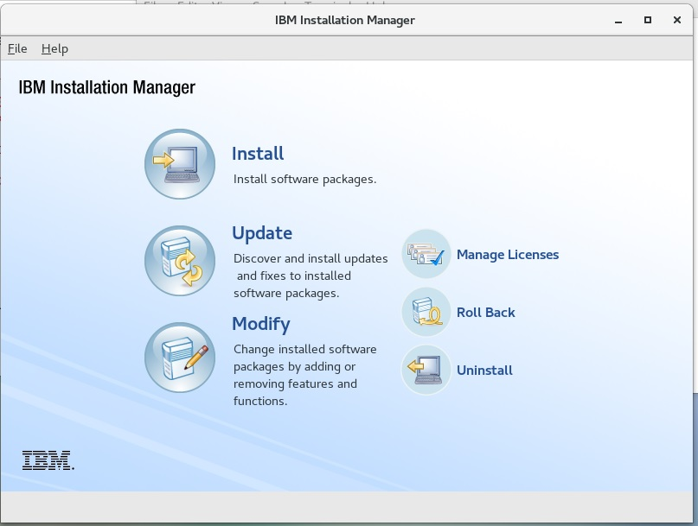

**Step 3:** Select IBM HTTP Server and then click “Next”.

Install Ins.Man.

Install IHS

Install Plugin

Install WCT

Define Webserv.

Plugin Propag.



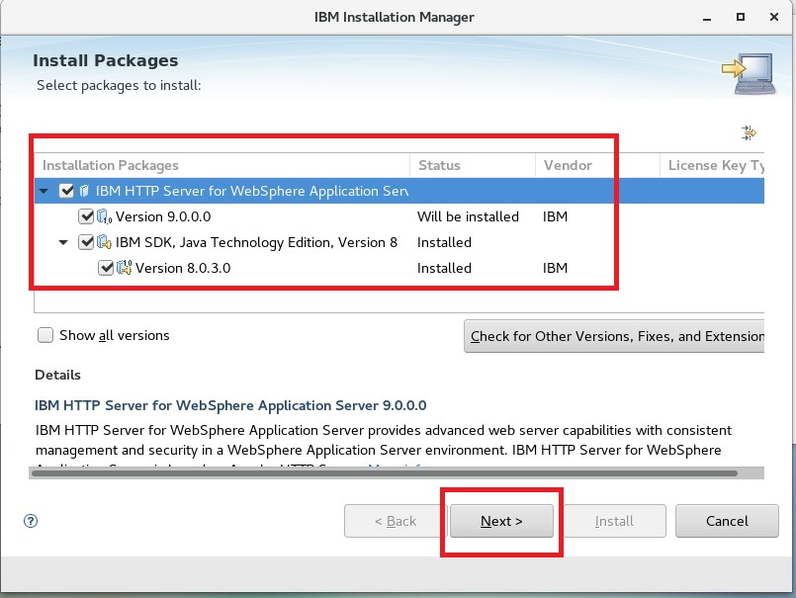

**Step 4:** Accept the license agreement and click “Next”.

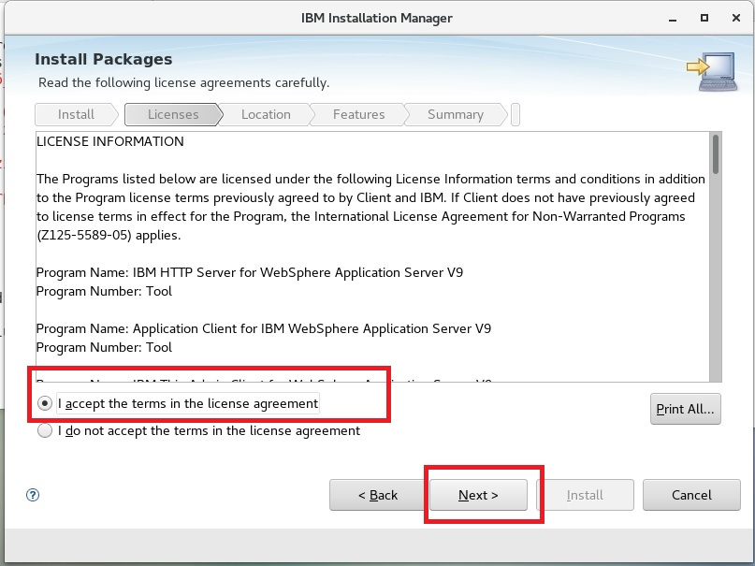

**Step 5:** Accept default directory (/opt/IBM/ HTTPServer) and click “Next”.

Install Ins.Man.

Install IHS

Install Plugin

Install WCT

Define Webserv.

Plugin Propag.



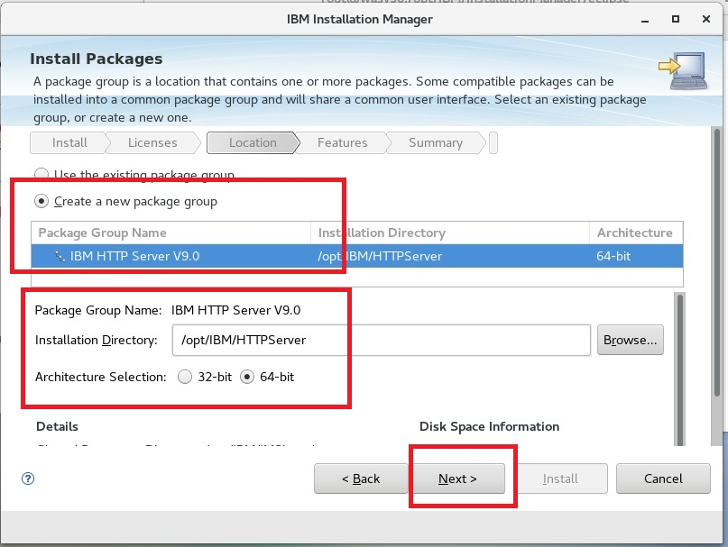

**Step 6:** Select language translation support and then click on “Next”.

Install Ins.Man.

Install IHS

Install Plugin

Install WCT

Define Webserv.

Plugin Propag.



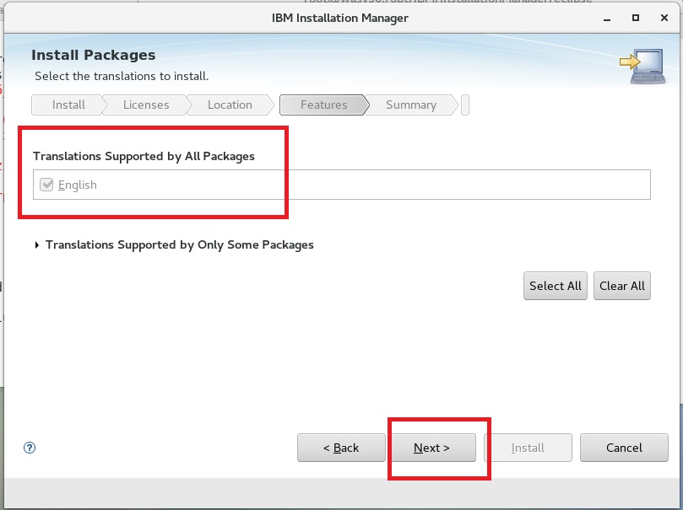

**Step 7:** Define the port that IHS will use (default is 80), we will use port 81 because default is already being used and click “Next”.

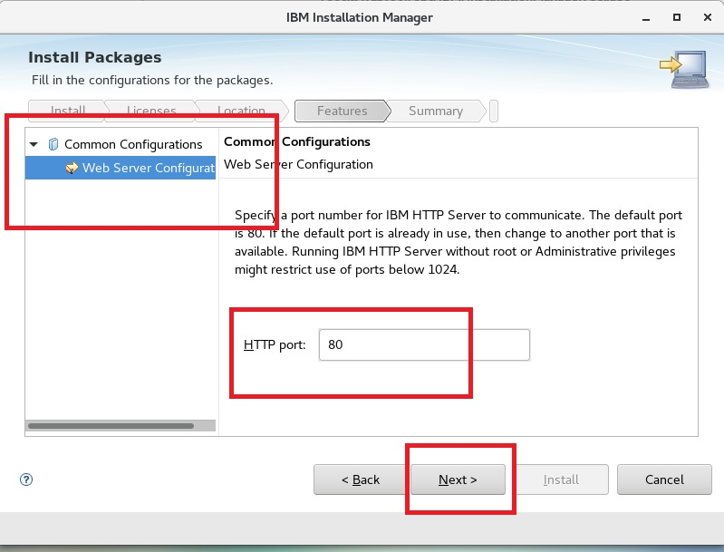

**Step 8:** Review the summary and then click “Install” to complete installation.

Install Ins.Man.

Install IHS

Install Plugin

Install WCT

Define Webserv.

Plugin Propag.



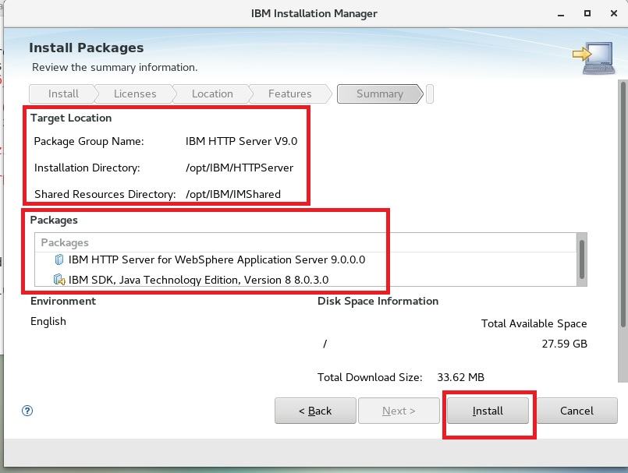

**Step 9:** Click “Finish” to finalize installation.

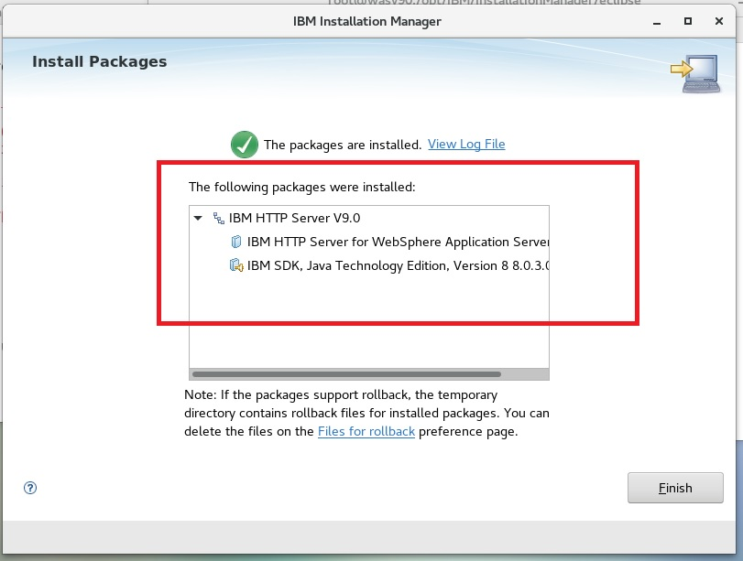

**Task 2 is complete!**

**Task 3: Install WebSphere Plug-ins**

Install Ins.Man.

Install IHS

Install Plugin

Install WCT

Define Webserv.

Plugin Propag.



**Step 1:** Start IBM Installation Manager issuing command “IBMIM” and add the repository via “File>Preferences”.

<http://www.ibm.com/software/repositorymanager/V9WASBase>

**Step 2:** Click “Install” to start installation.



Install Ins.Man.

Install IHS

Install Plugin

Install WCT

Define Webserv.

Plugin Propag.



**Step 3:** Select the “Web Server Plug-ins for IBM WebSphere Application Server” package and click “Next”.

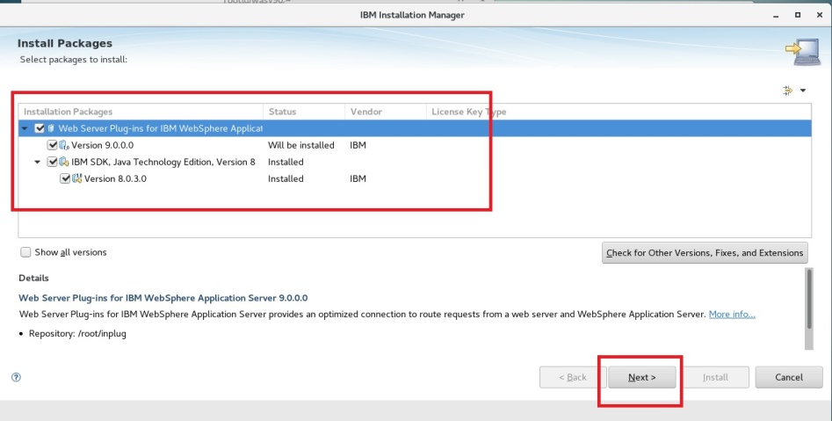

**Step 4:** Accept the license agreement and then click “Next” to continue.

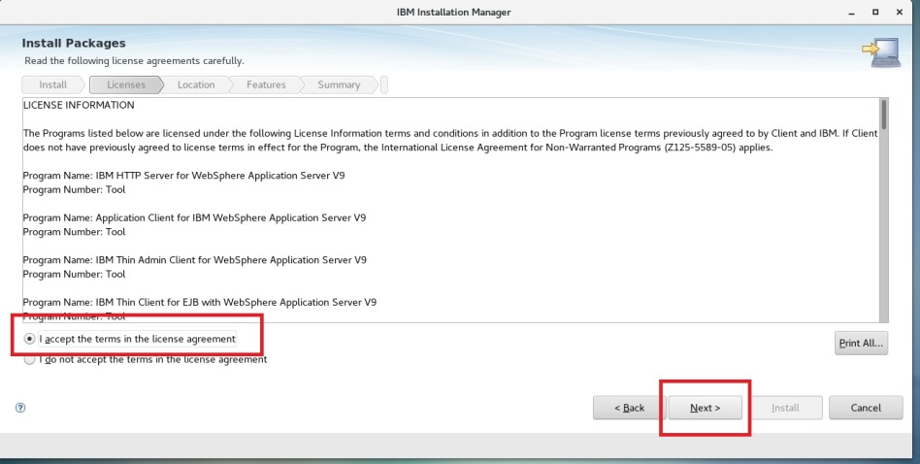

Install Ins.Man.

Install IHS

Install Plugin

Install WCT

Define Webserv.

Plugin Propag.



**Step 5:** Set the installation directory as /opt/IBM/WebSphere/Plugins and click “Next”.

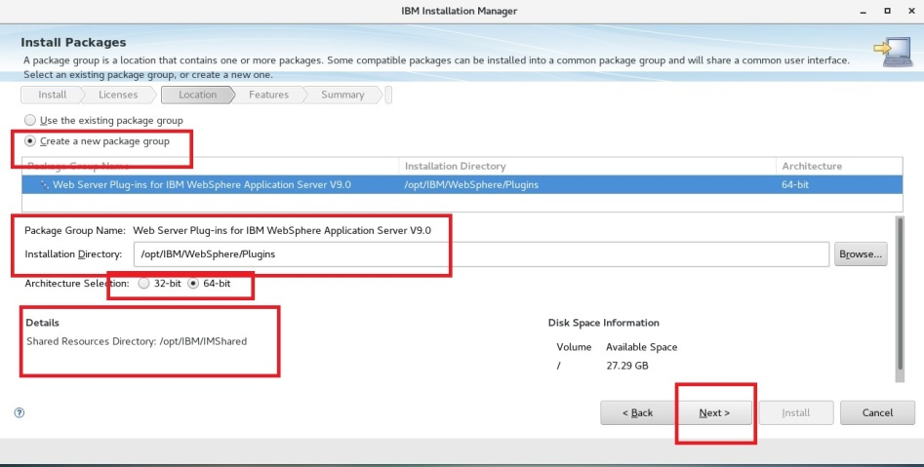

**Step 6:** Select the supported language and then click “Next”.

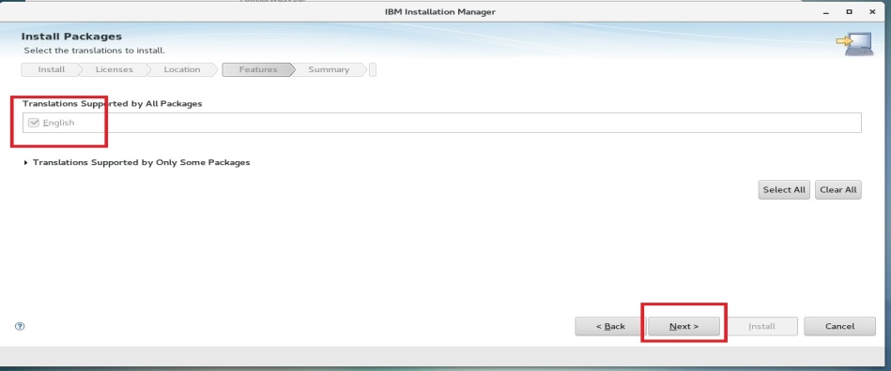

Install Ins.Man.

Install IHS

Install Plugin

Install WCT

Define Webserv.

Plugin Propag.



**Step 7:** Click “Install” to start installation.

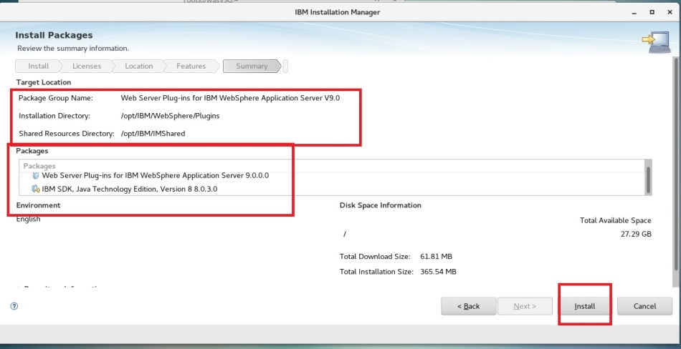

**Step 8:** Finalize installation by clicking “Finish”.

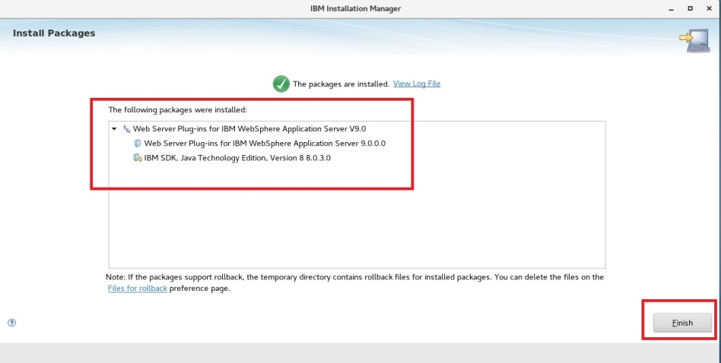

**Task 3 is complete!**

**Task 4: Install WebSphere Customization Toolbox**

Install Ins.Man.

Install IHS

Install Plugin

Install WCT

Define Webserv.

Plugin Propag.



**Step 1:** Start IBM Installation Manager issuing command “IBMIM” under the directory “/opt/IBM/InstallationManager/eclipse”. Add the repository via “File>Preferences”.

<http://www.ibm.com/software/repositorymanager/V9WASBase>

**Step 2:** Click “Install” to start installation.

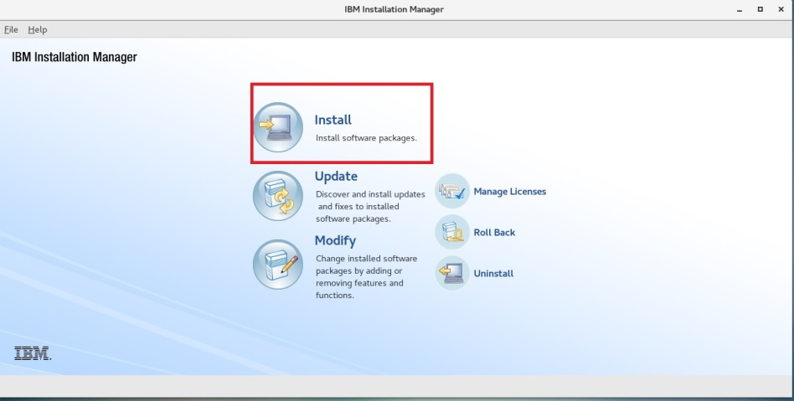

Install Ins.Man.

Install IHS

Install Plugin

Install WCT

Define Webserv.

Plugin Propag.



**Step 3:** Select “WebSphere Customization Toolbox” to install and click “Next”.

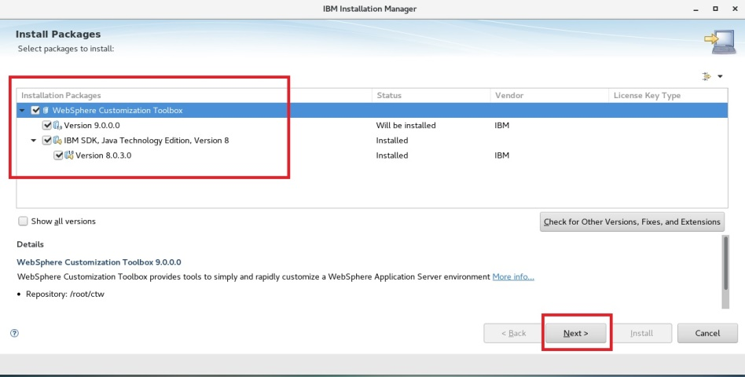

**Step 4:** Accept the license agreement to continue and then click “Next”.

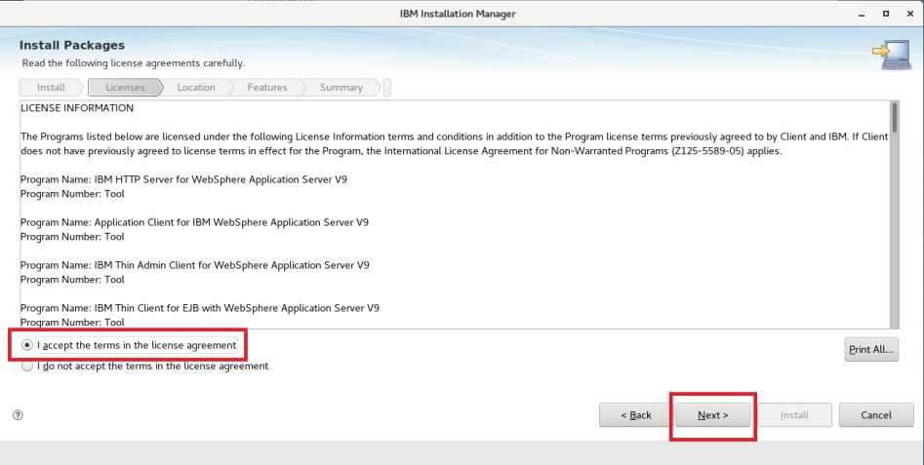

**Step 5:** Use the default installation directory, “/opt/IBM/WebSphere/Toolbox” and click “Next”.

Install Ins.Man.

Install IHS

Install Plugin

Install WCT

Define Webserv.

Plugin Propag.



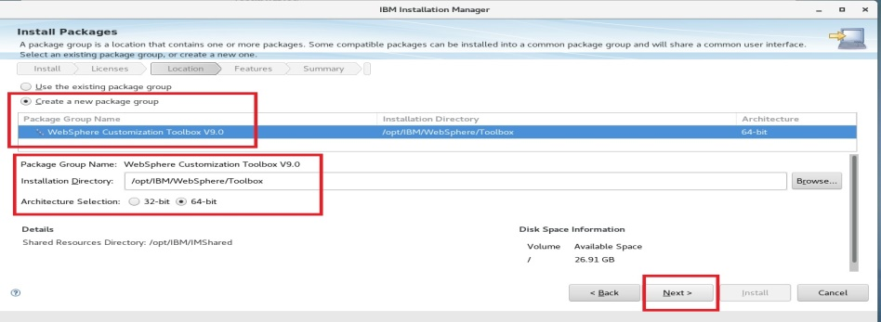

**Step 6:** Select language and features to install and click “Next”.

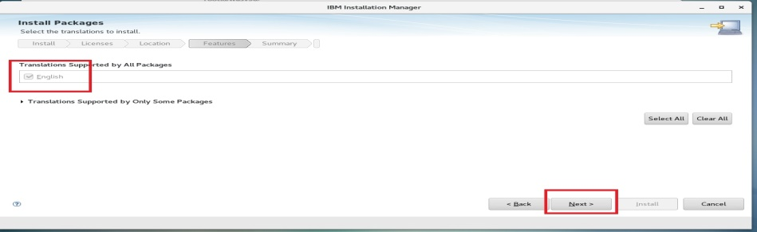

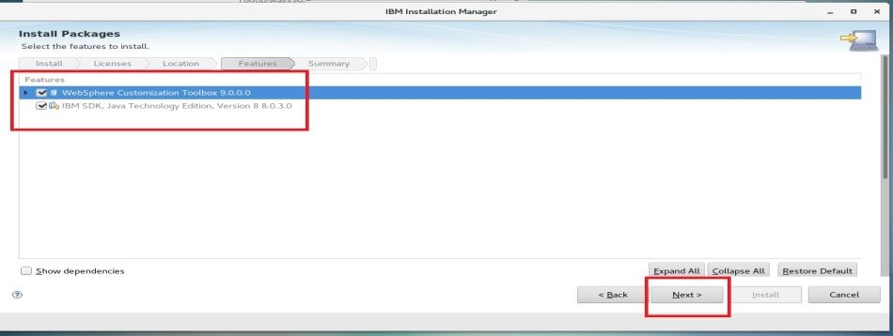

**Step 7:** Click “Install” to start installing files.

Install Ins.Man.

Install IHS

Install Plugin

Install WCT

Define Webserv.

Plugin Propag.



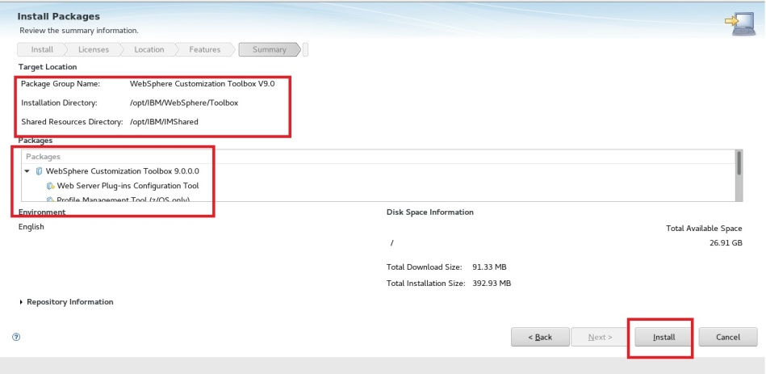

**Step 8:** Click “Finish” to finalize installation.

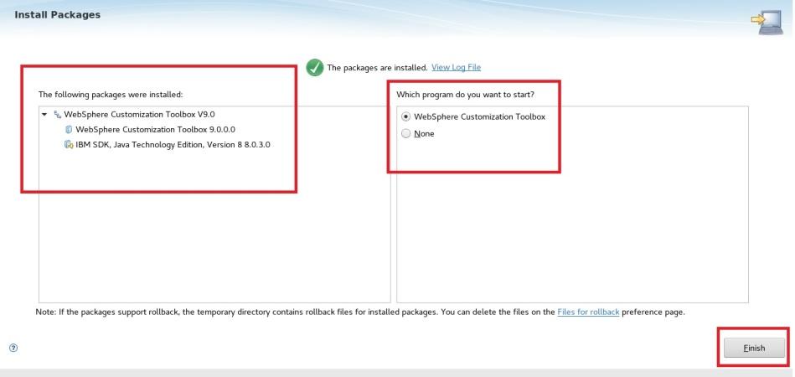

**Task 4 is complete!**

**Task 5: Create web server definition**

Install Ins.Man.

Install IHS

Install Plugin

Install WCT

Define Webserv.

Plugin Propag.



**Step 1:** Start WebSphere Customization Toolbox by issuing “wct.sh” command under “/opt/IBM/WebSphere/Toolbox/WCT” directory.

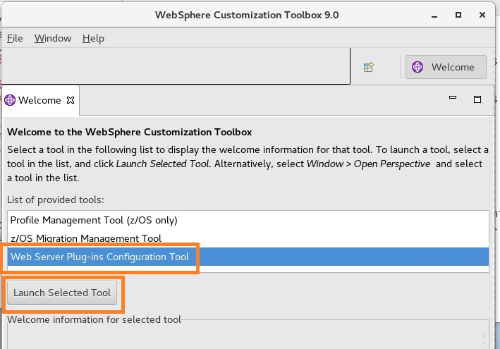

**Step 2:** Click “Add” to create a new plug-in runtime.

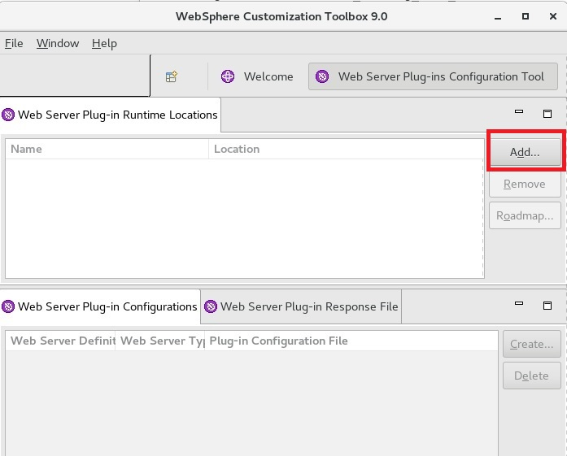

**Step 3:** Give a unique name as for definition and set the location of the Plugin-ins home directory, then click “Finish”.

Install Ins.Man.

Install IHS

Install Plugin

Install WCT

Define Webserv.

Plugin Propag.



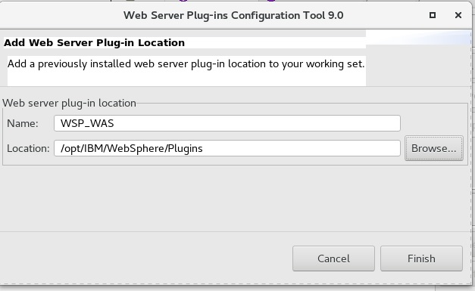

**Step 4:** Click “Create” to add a web server definition.

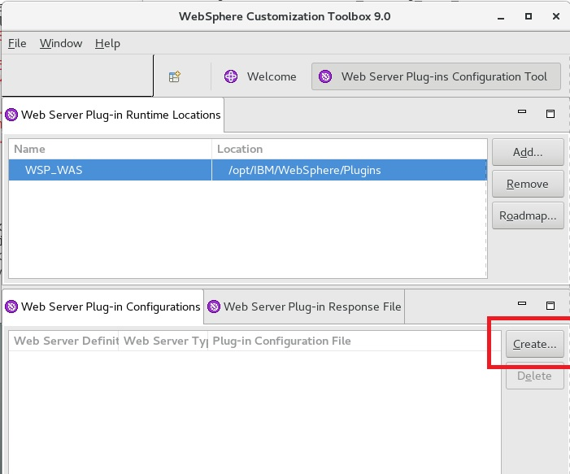

**Step 5:** Select “IBM HTTP Server v8.5” and click “Next”.

Install Ins.Man.

Install IHS

Install Plugin

Install WCT

Define Webserv.

Plugin Propag.



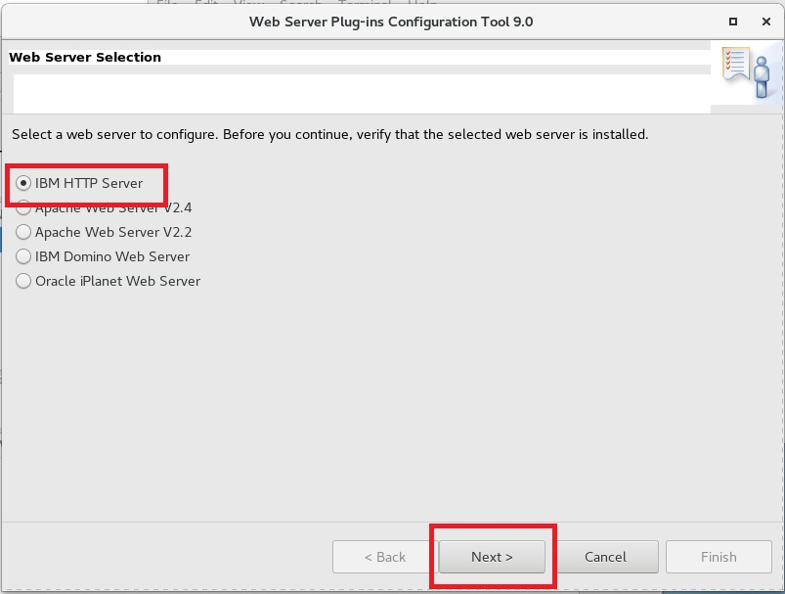

**Step 6:** Select the architecture (32 bit or 64 bit) and then click “Next”

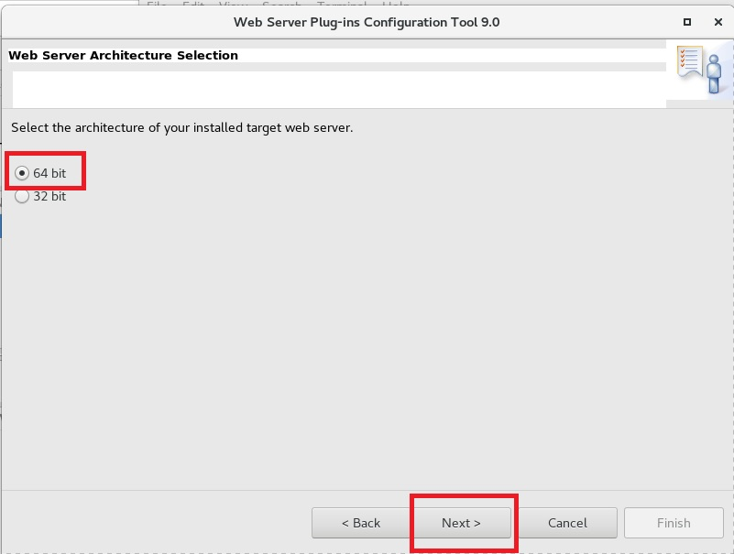

**Step 7:** Select the IBM HTTP Server conf file and web server port. (/opt/IBM/HTTPServer/conf/httpd.conf, port 81)

Install Ins.Man.

Install IHS

Install Plugin

Install WCT

Define Webserv.

Plugin Propag.



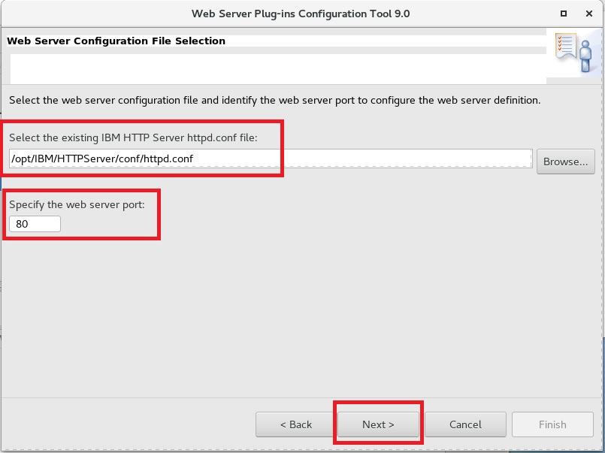  
**Step 8:** Mark “Setup IBM HTTP Server Administration Server” and use ‘8008’ as “HTTP Administration Port”. Enter credentials for the IHS administration and click “Next”.

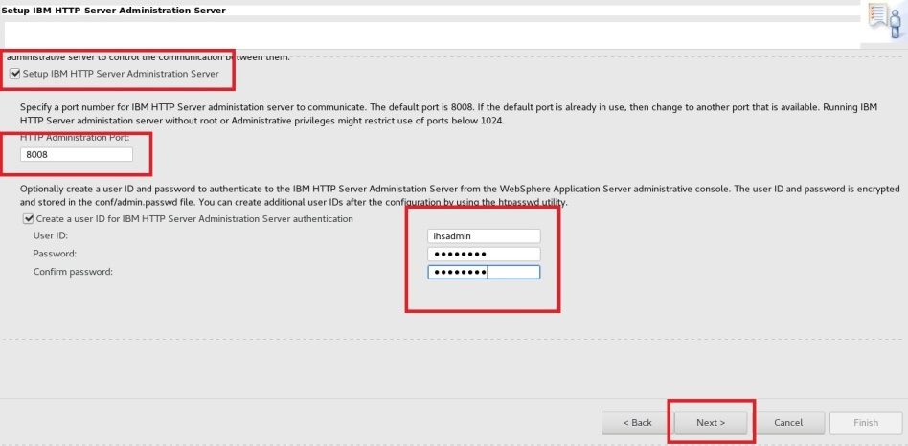

**Step 9:** Specify the system user and group that can write to configuration files of IHS and Plugins.

Install Ins.Man.

Install IHS

Install Plugin

Install WCT

Define Webserv.

Plugin Propag.



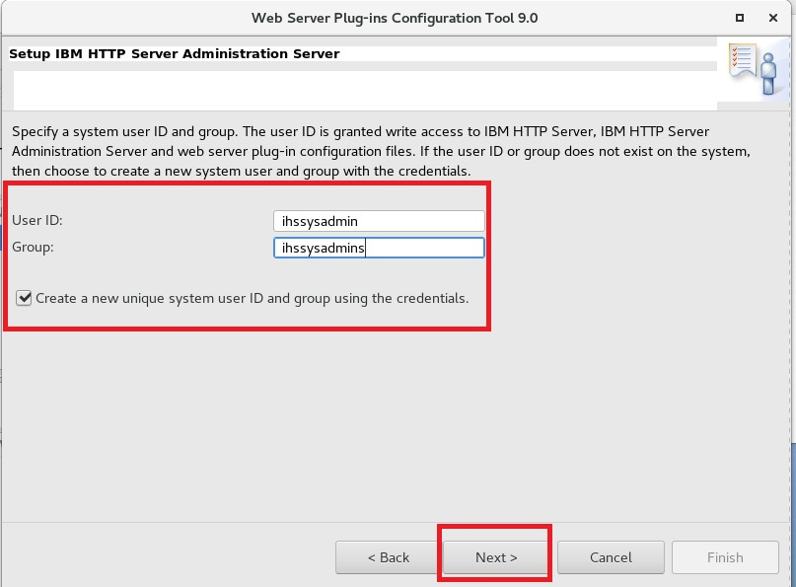  
**Step 10:** Define a unique name for the web server definition.

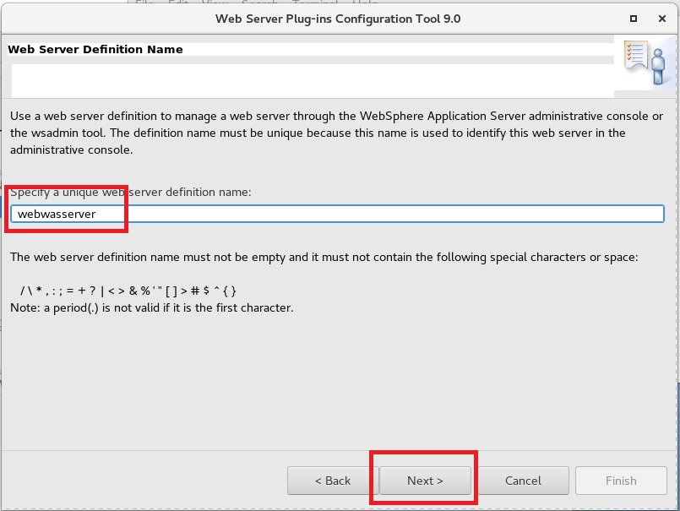

**Step 11:** Specify the hostname or IP address of the application server and then click “Next”. Select Profile and Next.

Install Ins.Man.

Install IHS

Install Plugin

Install WCT

Define Webserv.

Plugin Propag.



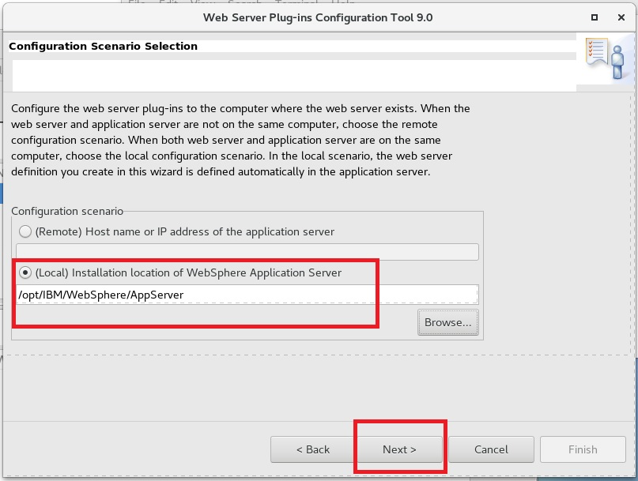

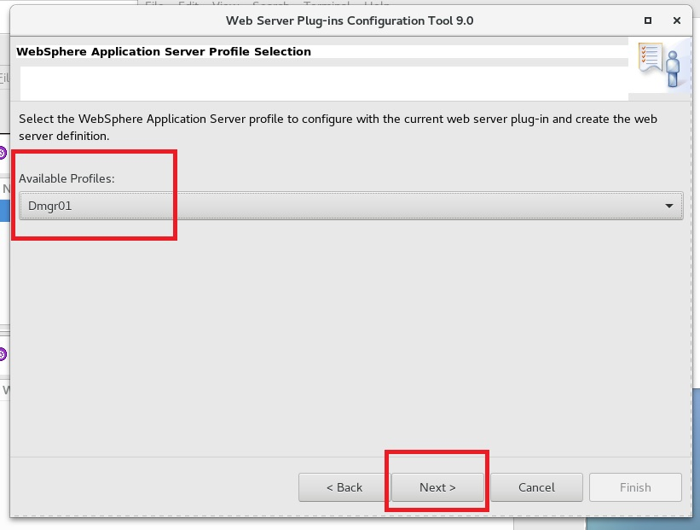

**Step 12:** Review the summary and then click “Configure”.

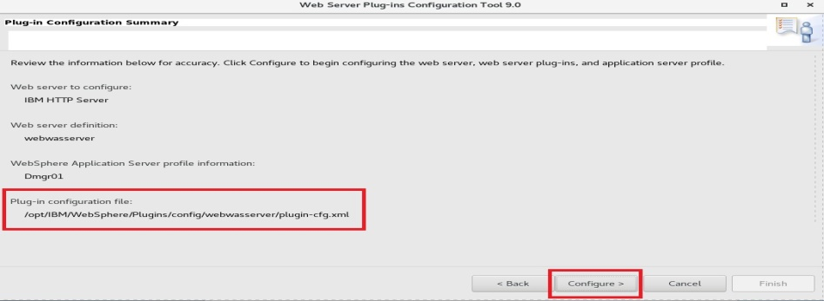

**Step 13:** Click “Finish” to complete configuration.

Install Ins.Man.

Install IHS

Install Plugin

Install WCT

Define Webserv.

Plugin Propag.



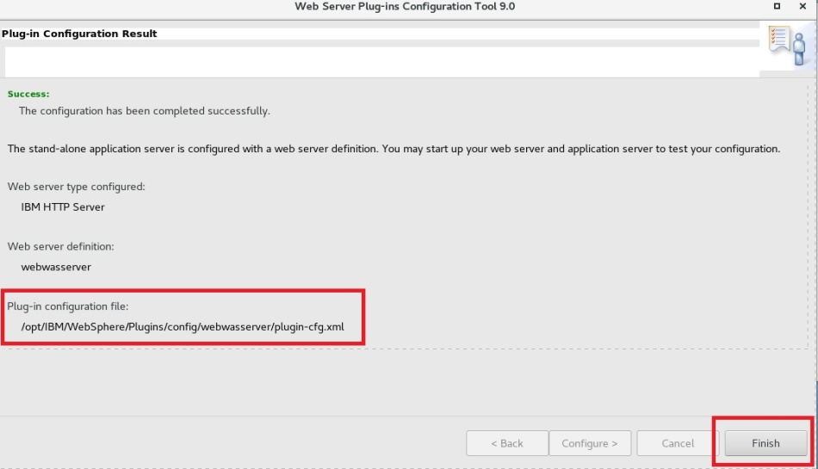 **Step 14:** This page will guide you complete the rest of the steps.  
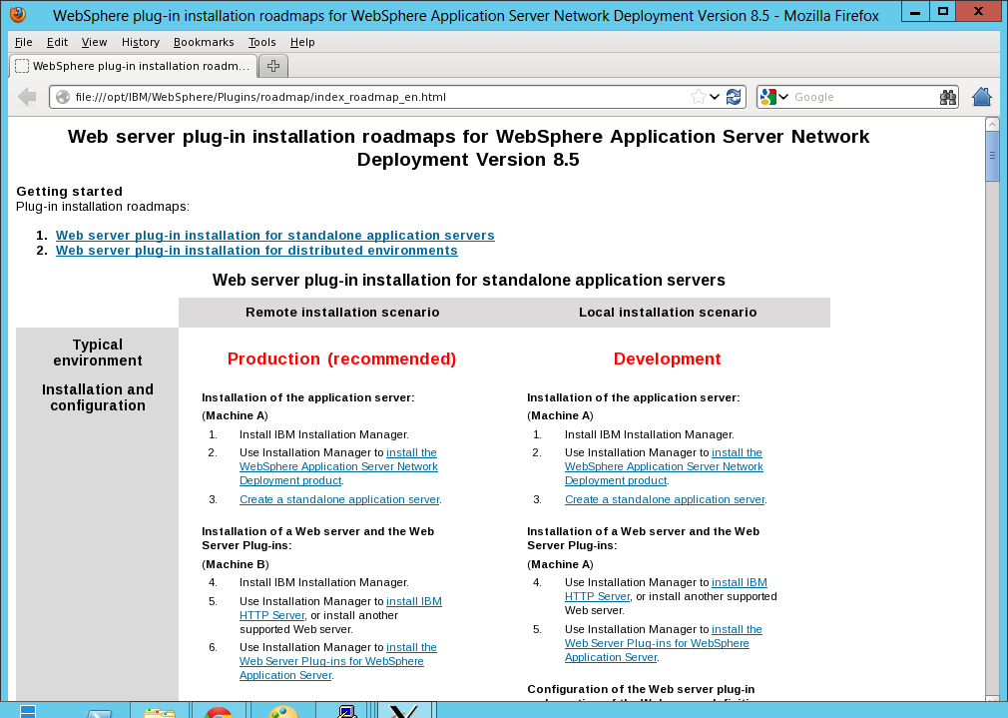

**Step 15:** Find newly created configuration script under “/opt/IBM/WebSphere/Plugins/bin” directory, with name “configure*webserver_name*.sh”. Copy that file to the application server bin directory.”/opt/IBM/WebSphere/AppServer/bin/”.

Install Ins.Man.

Install IHS

Install Plugin

Install WCT

Define Webserv.

Plugin Propag.



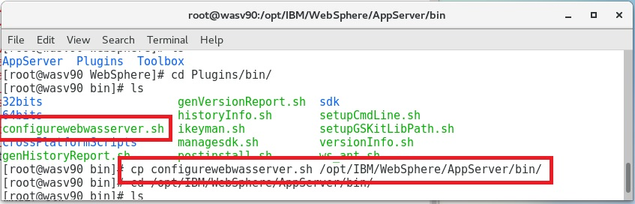 **Step 16:** On application server, run the configuration script.

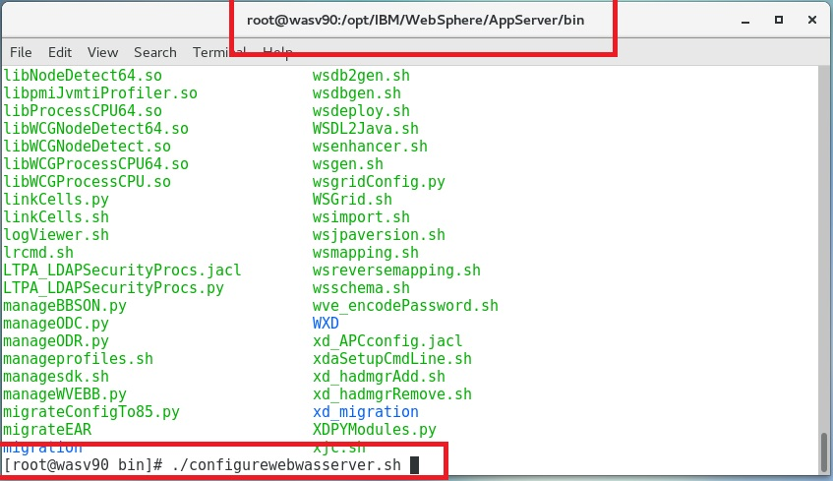

**Step 17:** You should see the configuration summary and the success message.

Install Ins.Man.

Install IHS

Install Plugin

Install WCT

Define Webserv.

Plugin Propag.



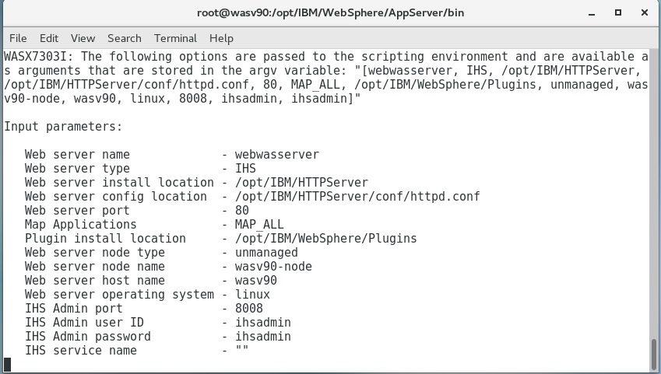

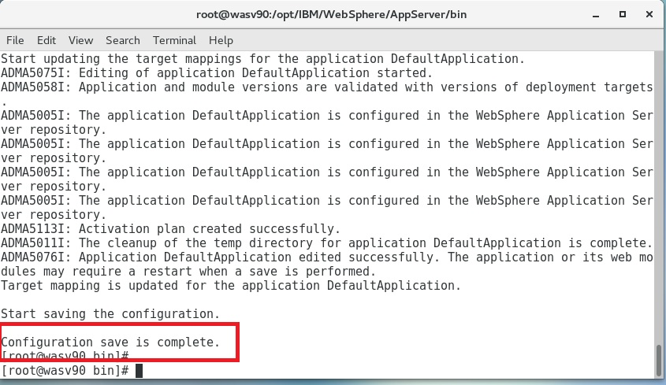

**Step 18:** Login to administration console, check whether newly added web server is listed under “Servers>Server Types>Web servers”.

Install Ins.Man.

Install IHS

Install Plugin

Install WCT

Define Webserv.

Plugin Propag.



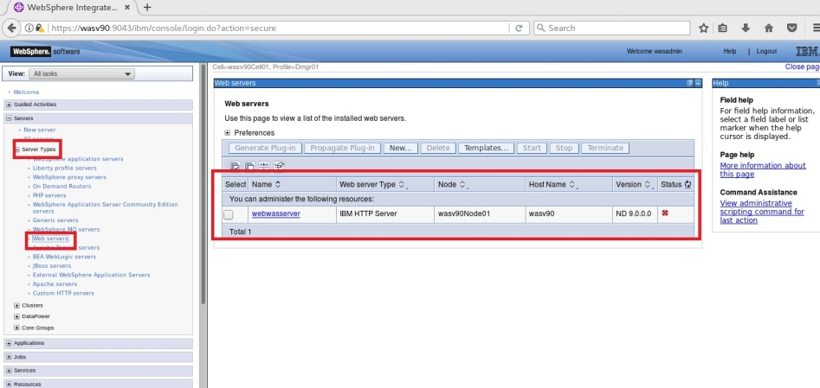

**Task 5 is complete!**

**Task 6: Generate and propagate plug-in**

Install Ins.Man.

Install IHS

Install Plugin

Install WCT

Define Webserv.

Plugin Propag.



**Step 1:** Login to admin console and select the web server under “Servers>Server Types>Web servers” and then click “Start” to start.  
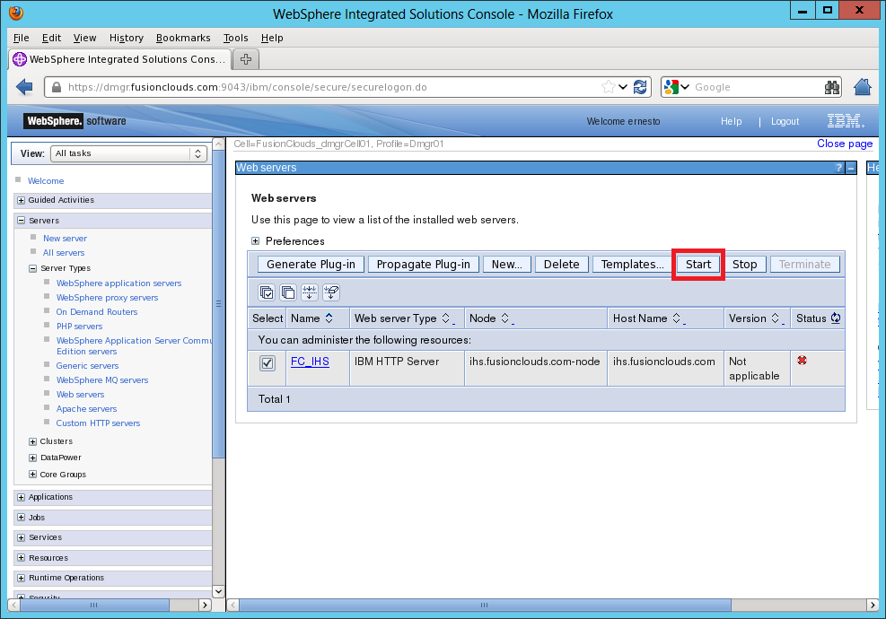  
 **Step 2:** Make sure that IHS is started.

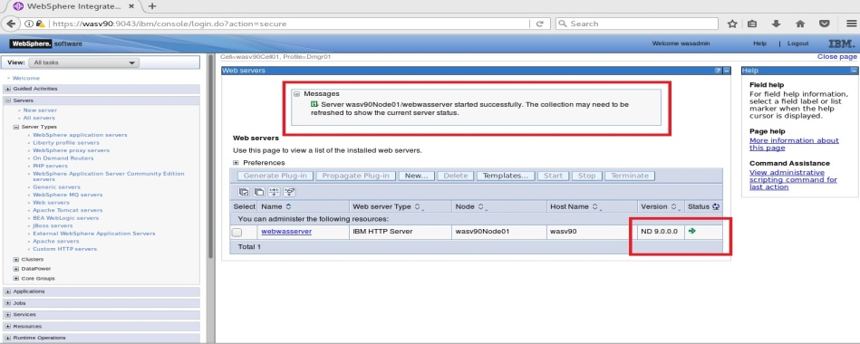

**Step 3:** Check if your web server is working.

Install Ins.Man.

Install IHS

Install Plugin

Install WCT

Define Webserv.

Plugin Propag.



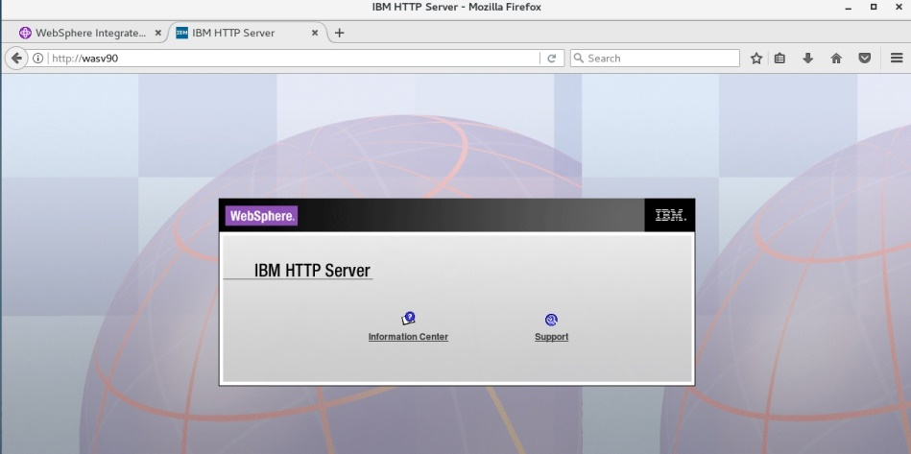

**Step 4:** Select the web server and then click “Generate Plug-in”.

Install Ins.Man.

Install IHS

Install Plugin

Install WCT

Define Webserv.

Plugin Propag.



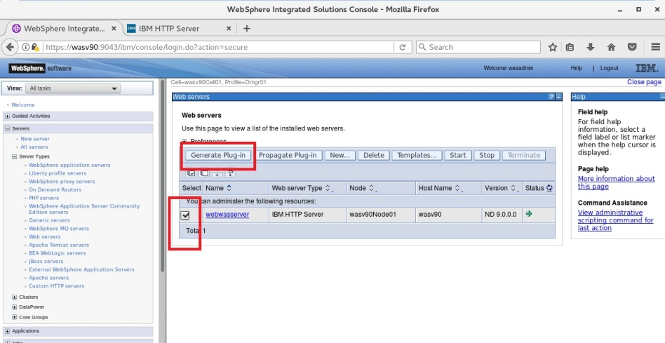

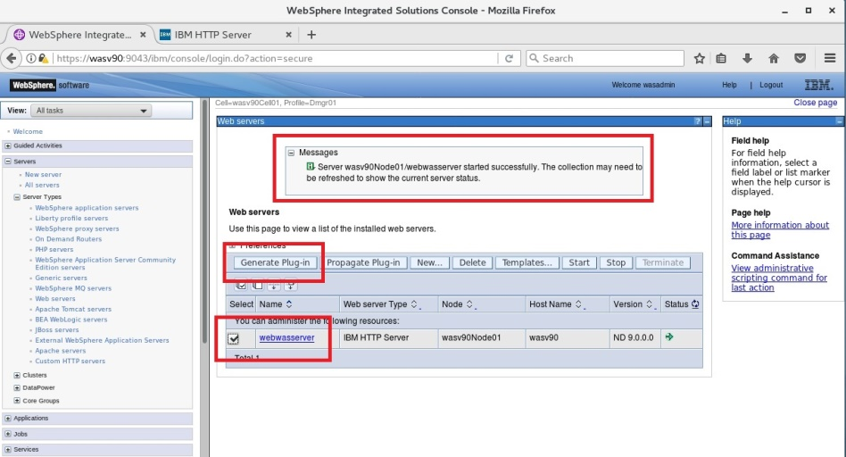

**Step 5:** Select the web server and then click on “Propagate Plug-in”.

Install Ins.Man.

Install IHS

Install Plugin

Install WCT

Define Webserv.

Plugin Propag.



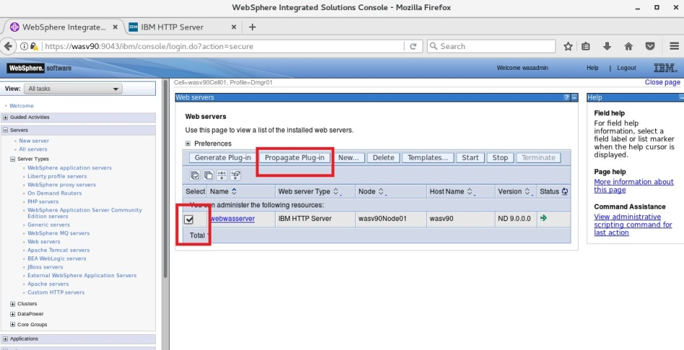

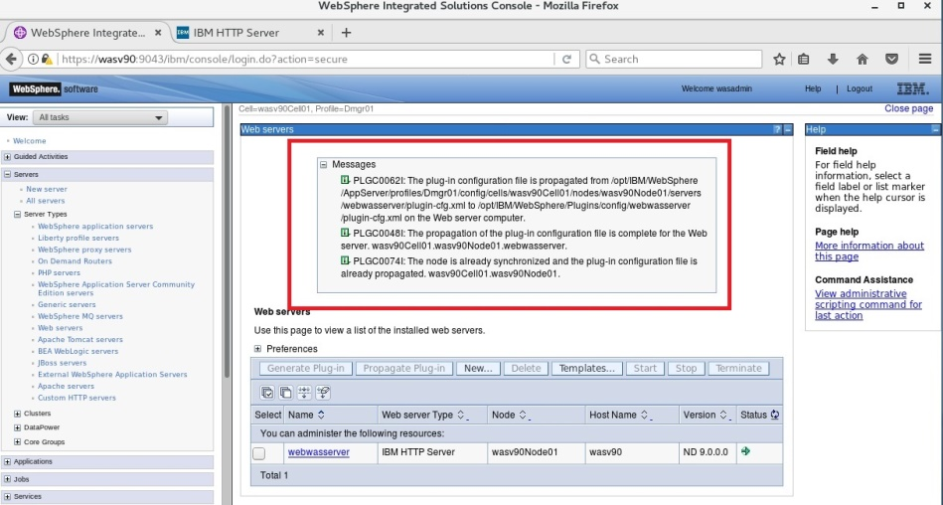

**Step 6:** In order to take changes affect, you need to restart the web server. Select the web server and then click “Stop”.

Install Ins.Man.

Install IHS

Install Plugin

Install WCT

Define Webserv.

Plugin Propag.



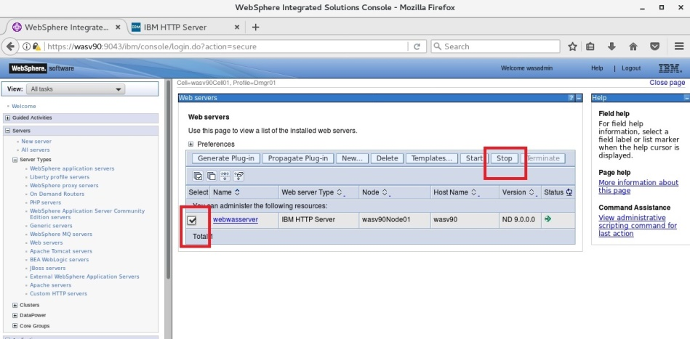

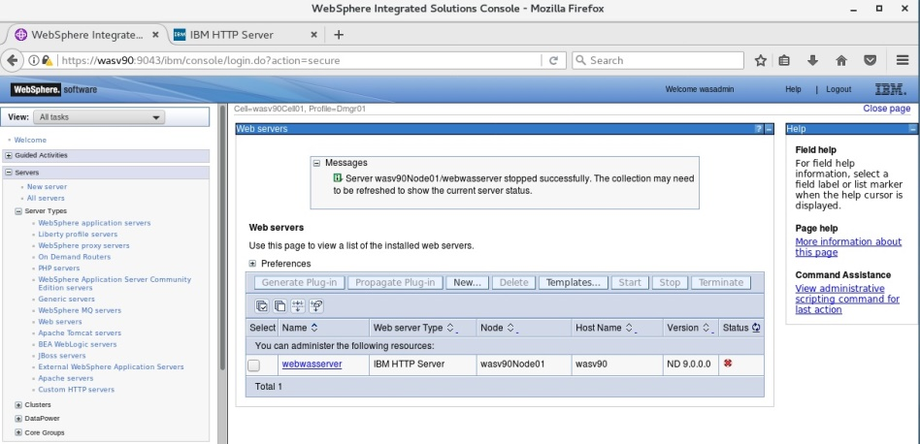

**Step 7:** To start, select the web server and then click “Start”.

Install Ins.Man.

Install IHS

Install Plugin

Install WCT

Define Webserv.

Plugin Propag.



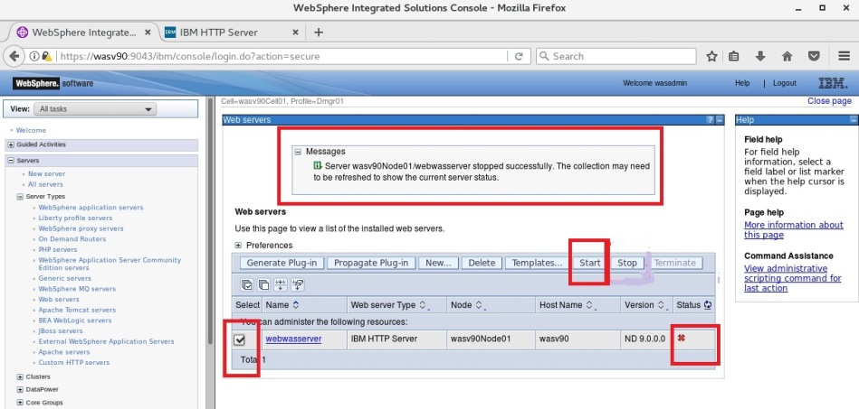

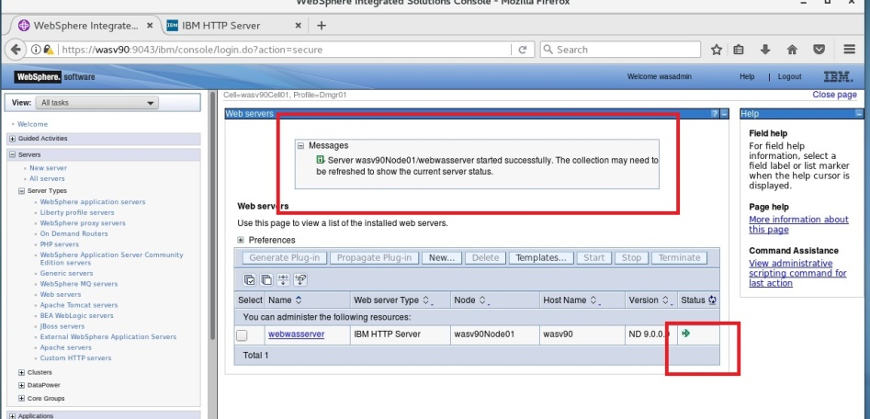

**Step 8:** Alternatively, you can use command line commands to restart web server.

Install Ins.Man.

Install IHS

Install Plugin

Install WCT

Define Webserv.

Plugin Propag.



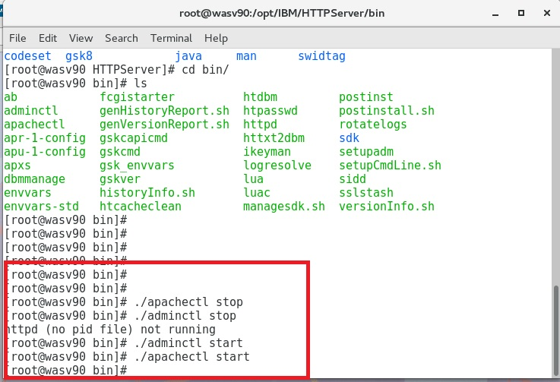

**Step 9:** To test the plugin generation and propagation, we can use the “Default Application” deployed during the installation of WebSphere Application Server. Type the URL “http://URL_of_webserver/snoop”. (eg. http://wasv90/snoop)

Install Ins.Man.

Install IHS

Install Plugin

Install WCT

Define Webserv.

Plugin Propag.



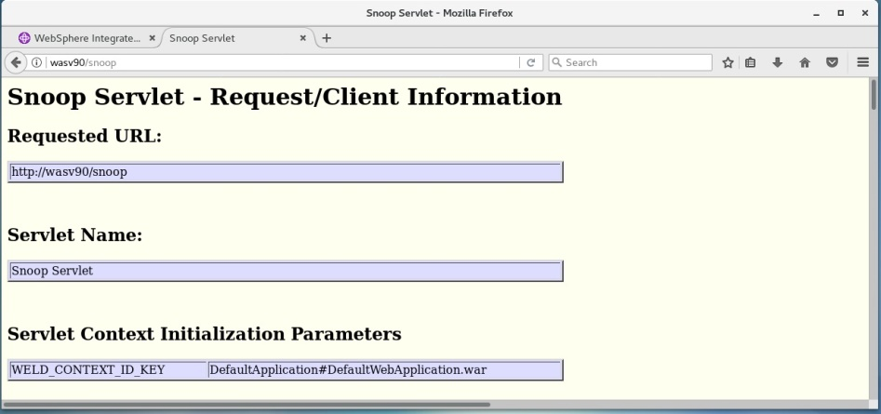

**Task 6 is complete!**

# SUMMARY

Web servers are one of the most important components of the multi-tier architectures. Numerous numbers of web servers such as Apache HTTP Server, Microsoft IIS, and IBM HTTP Server, are supported by IBM WebSphere Application Server. WebSphere Plug-ins provides better performance and security by adding a smart layer between the web server and WebSphere Application Server. For easier and better configuration of plug-in, IBM has introduced a tool as part of the WebSphere Customization Toolbox, called “Web Server Plug-ins Configuration Tool”. Web servers can be managed via administrative console where you can generate and propagate the plug-in configuration for the applications that are configured in the application server.

# REFERENCES

* http://www-01.ibm.com/support/knowledgecenter/SSAW57_8.5.5/com.ibm.websphere.ihs.doc/ihs/welcome_ihs.htmlhttp://www.ibm.com/developerworks/websphere/library/samples/SampleScripts.html
* http://pic.dhe.ibm.com/infocenter/wasinfo/v8r5/index.jsp?topic=%2Fcom.ibm.websphere.nd.doc%2Fae%2Ftins_manualWebIHS80.html
* http://pic.dhe.ibm.com/infocenter/wasinfo/v7r0/index.jsp?topic=/com.ibm.websphere.nd.doc/info/ae/ae/tins_road_plugins.html

# INDEX

Apache HTTP Server 124

IBM HTTP Server 124

IHS 124

managed 124

plug-in 124

*plugin-cfg.xml* 124

unmanaged 124

Web Server Plug-ins Configuration Tool 125

WebSphere Customization Toolbox 125